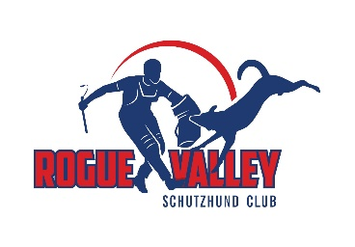 ROGUE VALLEY SCHUTZHUND CLUB 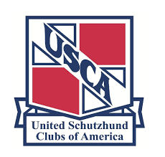
United Schutzhund Clubs of America Sanctioned Trial
May 25th & 26th 2024
USCA Judge Stanley Craddock
Helper: Eddie Hayes
Central Point, Oregon

PRE-ENTRY REQUIRED
Entries may be limited, so Pre-Entries will be required. Entries must be received by May 20, 2023
TITLES OFFERED
IGP1-3, GPr1-3, UPr1-3, FPr1-3, Stp1-3, RH, RH-F-1, RH-FL-1, FH-V, BH-VT, AD

SCHEDULE OF EVENTS
Saturday May 25th, 7:00 AM IGP Tracking. Obedience and Protection to follow. Sunday May 26th, AD 7:00 AM, RH tofollow
Obedience and Protection will be judged immediately following Tracking at our home field located at 3039 Hanley Rd., Central Point, Or. 97502
Location for tracking will be about 2 miles from our home field. Tracking will be on plowed dirt.
TRIAL FEES
BH VT – USCA members $85 – Non USCA members $135
Other titles – USCA members $100 – Non USCA members $150

QUESTIONS AND INQUIRIES
Diane Griffin, Trial Secretary (541) 672-3331, E-mail: alewyfe@outlook.com

AGREEMENT TO HOLD HARMLESS
WAIVER AND ASSUMPTION OF RISK

I, the undersigned, understand attendance at a club trial, seminar, or training session is not without risk to me, members of my family, my dog, or any guests attending these functions. I realize dogs may cause injury even when handled with the highest level of care. I hereby waive and release the Rogue Valley Schutzhund Club (hereinafter referred to as “RVSC”) officers, members, guests, and other agents from any and all liability of any nature, for injury or damage resulting from the actions of any dog, individual, or training activity, and I expressly assume the risk of any such damage or injury while attending any activity or function held by “RVSC” or on any grounds used by “RVSC” in association with “RVSC” activities. I also agree to release from responsibility any person or company upon whose property “RVSC” may be holding any activity.

I hereby agree to indemnify and hold harmless “RVSC”, officers, members, or guests freed of any and all claims, or claims by any member of my family or any other person accompanying me to any activity held or sponsored by “RVSC” or while on grounds used for “RVSC” activities or the surrounding areas thereto as a result of any action by any dog, person, or activity, including those of myself, my family members, or guests.

SIGNATURE_______________________________________________________Date________________

PRINT NAME______________________________________________________

E-MAIL____________________________________________Phone______________________________

WITNESS:____________________________________________________Date:________________

